**SEISMIC VULNERABILITY INDEX OF MICROTREMOR (SVIM)**

**USER MANUAL**



v.1.1

Aulia Khalqillah, S.Si., M.Si

Prof. Muksin Umar

Tsunami and Disaster Mitigatioin Research Center (TDMRC)

Universitas Syiah Kuala

# Introduction

The Seismic Vulnerability Index of Microtremor (SVIM) is a program to conduct microtremor data processing in MATLAB based. The principal computation in SVIM is to identify the fundamental frequency ($f_{0}$) and amplification factor ($A_{0}$) of a site by using(Nakamura, 1989) called Horizontal to Vertical Spectral Ratio (HVSR). The $f_{0}$ is identified from the maximum value of $A_{0}$ or equivalent to clear peak of smoothed HVSR curve as shown in Figure 1. The HVSR curve is smoothed using Konno-Ohmachi method. (Konno & Ohmachi, 1998). By using the $f_{0}$ and $A_{0}$, the seismic vulnerability index ($K_{g}$) is calculated directly in SVIM for each microtremor data. The SVIM program also has the mapping feature. This feature can be used to identify the data distribution of $f_{0}, A_{0}$ and $K_{g}$ as preliminary view.

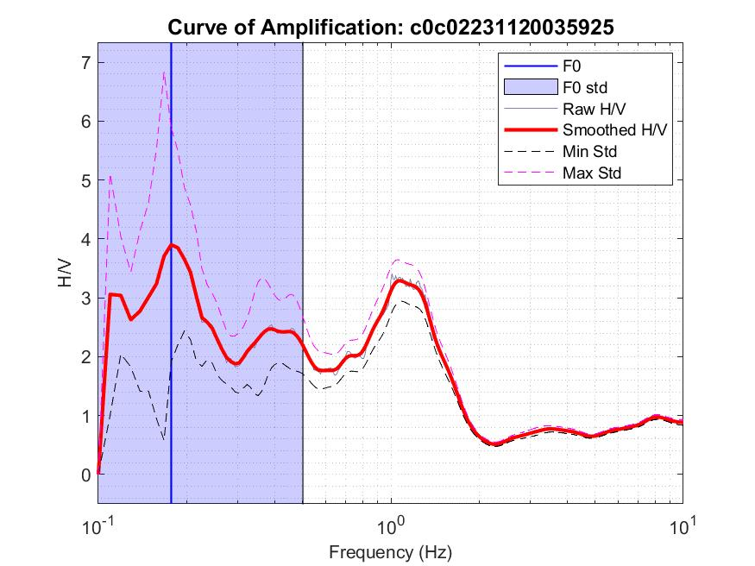

Figure 1. An example of $f_{0}$ is identified from the maximum of $A_{0}$ or H/V value

# Preparation

There are two directories in main SVIM directory:

1. mseed: there are function to read and write a trace data to mini-SEED format. This function is created by [François Beauducel](https://www.mathworks.com/matlabcentral/fileexchange/28803-rdmseed-and-mkmseed-read-and-write-miniseed-files).
2. src: there are function that support to calculation in SVIM program
   1. antrig1: detecting the ratio of STA/LTA
   2. cosinewin: creating a cosine taper
   3. idw1: interpolating data (map)
   4. kosmooth: Smoothing HVSR curve
   5. patchcolors: Coloring the window segment
3. Please provide MATLAB R2015b or latest. The SVIM has been tested in MATLAB R2015b and R2019b.

# Installation

1. Download SVIM from GitHub repository as a zip file and save in the proper directory.
2. Extract the file in the current directory and we have structure files and sub-directories as follows
   1. mseed (directory)
   2. src (directory)
   3. EXAMPLE (directory)
   4. SVIM.m
   5. mapsvim.m
   6. SVIM.fig
   7. mapsvim.fig
3. Open your MATLAB.
4. Click on the Set Path in the Toolbar area

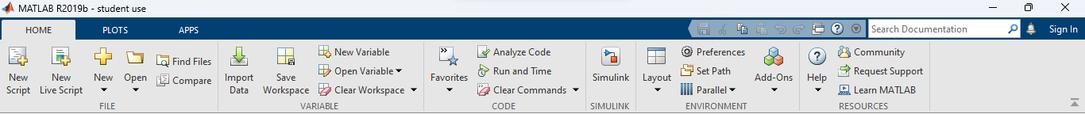

1. It will open a Set Path window as figure below. Click on the Add with Subfolders and select the SVIM main folder.

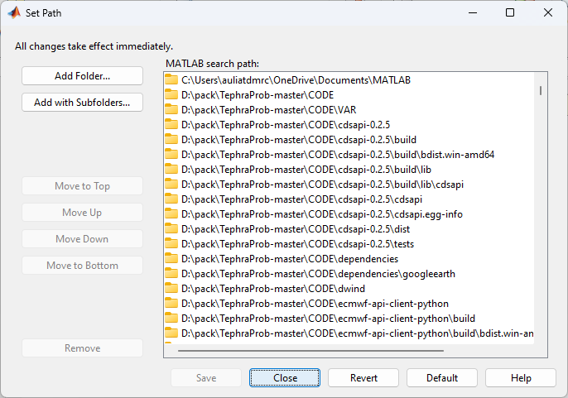

1. Then the SVIM functions and sub-directories have been loaded as figure below. Then click save then close.

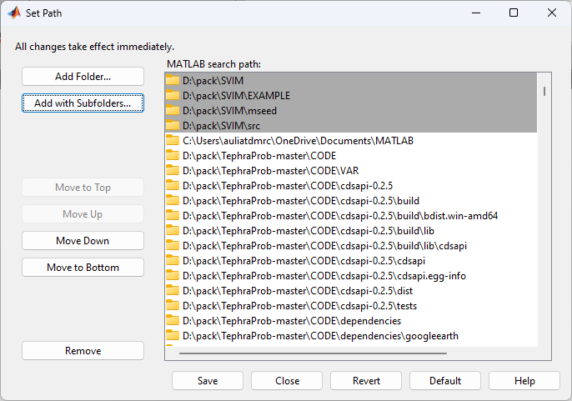

1. To check the installation, type *help SVIM* in MATLAB’s Command Window then press enter. It will show the information regarding SVIM as follows

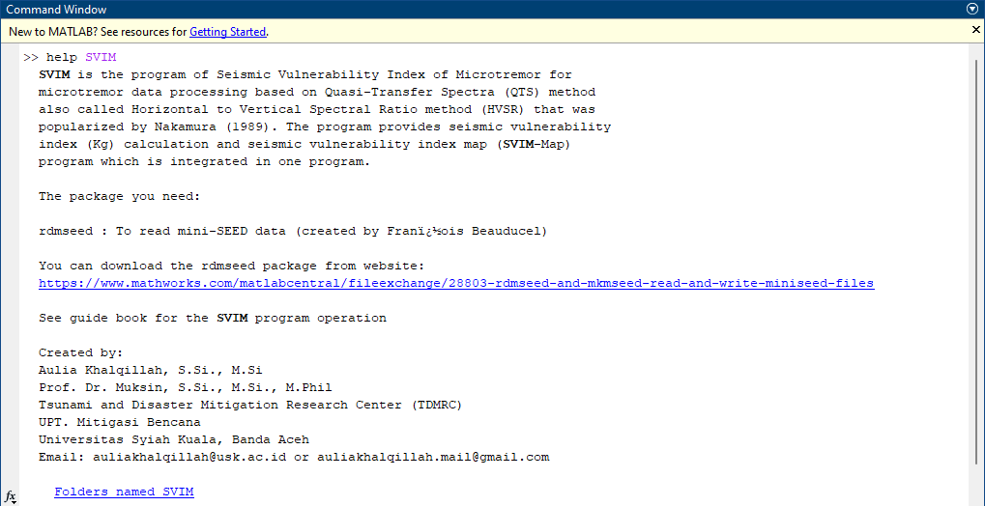

# Data Processing

The SVIM program allows to open trace data in mini-SEED (MSEED) format that is separated into three components, east (e), north (n) and vertical (z). In this package, there is a directory EXAMPLE that consist a set of example trace data, such as c0c02231120035925.bhe, c0c02231120035925.bhn, and c0c02231120035925.bhz. Furthermore, there is an example of output SVIM for several data processing that have done called Output_SVIM.txt. This file is used in SVIM-map to plot preliminary map. The all steps of data processing can be followed in the explanation below.

1. Type SVIM in the MATLAB’s command window and it will show the SVIM window as figure below.

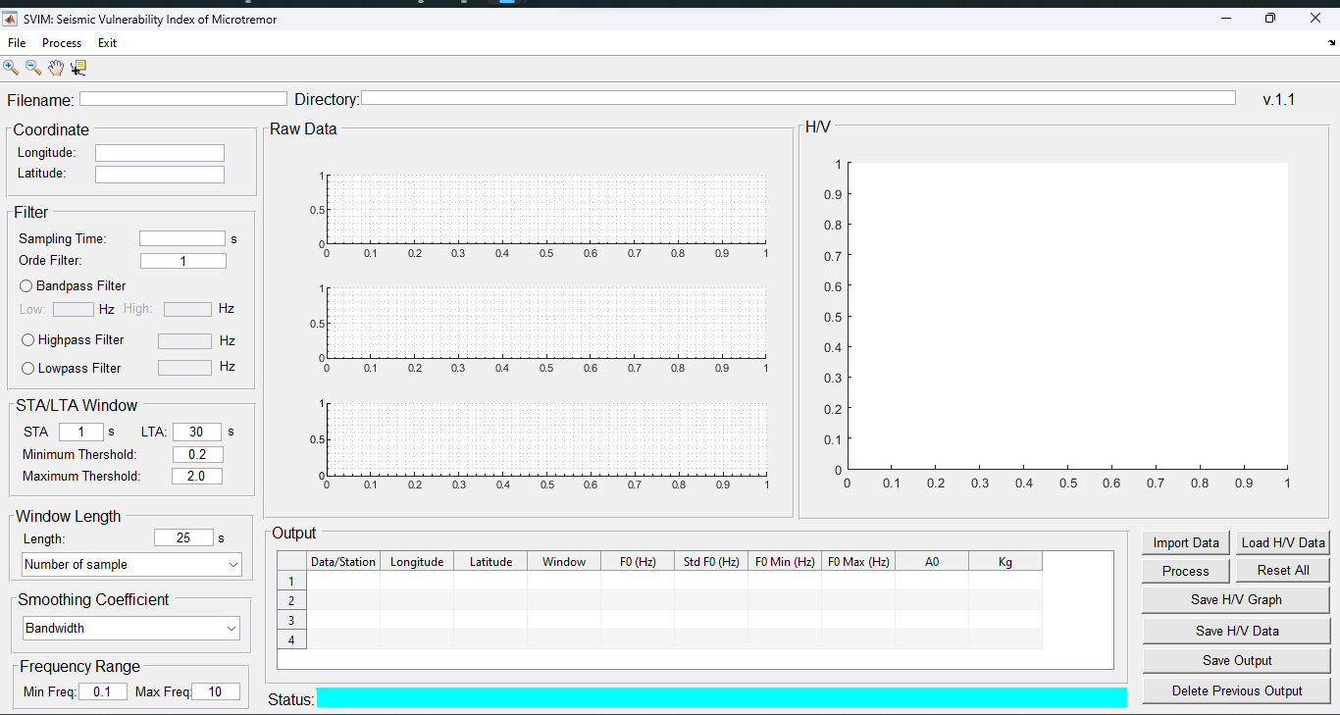

1. Click on **Import Data** button (ctrl + I) or in the toolbar click File 🡪 Import Raw Data, then select the example data from the EXAMPLE directory. Then, the raw data will show as figure below.

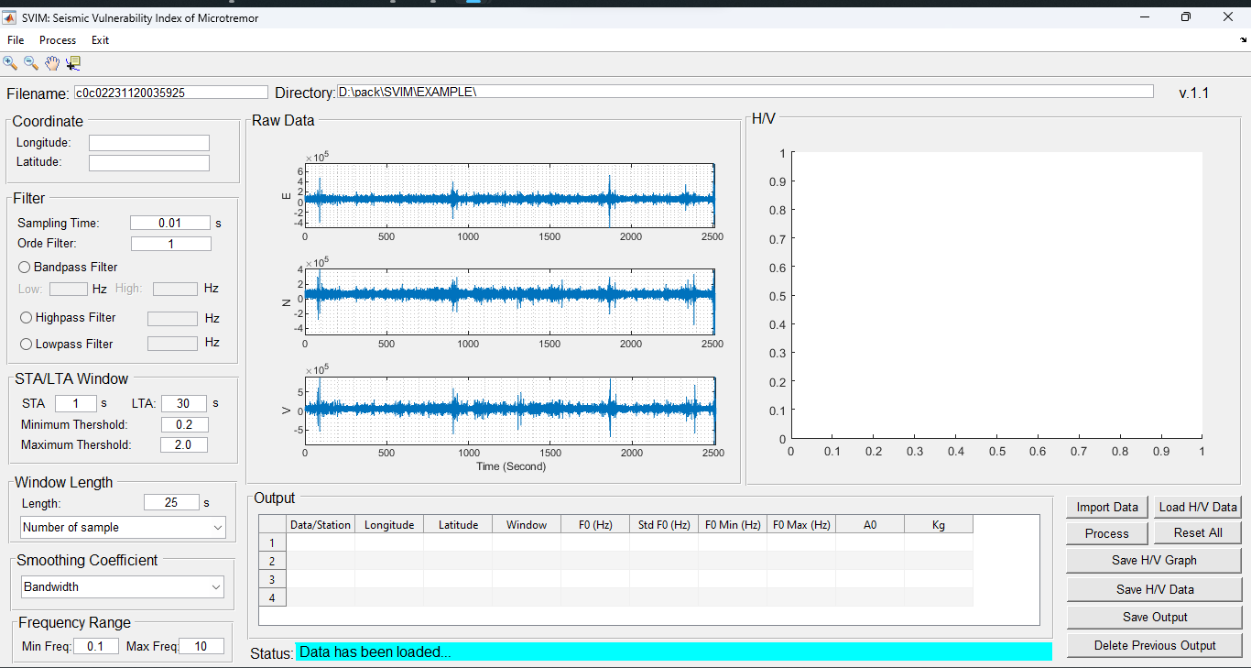

1. Fill the coordinate (longitude and latitude) that where the trace data has been collected, e.g., longitude is 95 and latitude is 5. These values will be stored into Output panel.
2. The sampling time is detected automatically from the data.
3. Adjust the Orde filter for the filter parameter. The default is 1.
4. Select one of three filter options, there are Bandpass filter, Highpass filter, and Lowpass filter. For example, Bandpass from 0.1 Hz (low) and 10 Hz (high).
5. Adjust the parameter of anti-trigger in STA/LTA window. The STA stands for Short Term Average and LTA for Long Term Average. The default parameter of STA is 1 s, LTA is 30 s, minimum threshold is 0.2, and maximum threshold 2.0. These parameters can be adjusted based on the data quality. Read Trnkoczy (1999) for more information about the fundamental of STA/LTA method.
6. Adjust the window length parameter. The default is 25 s
7. Select the number of samples. There are four options, 521, 1024, 2048, 4096. In this example, the 1024 is choosen.
8. Select the bandwidth of smoothing coefficient. There are six options, 10, 20, 30, 40, 50, and 60. In this example, the 40 is choosen.
9. Set the frequency range for the HVSR curve. The default is 0.1 Hz to 10 Hz.
10. After all parameters have been adjusted, then click Process button (ctrl + S) or in the toolbar click **Process** 🡪 H/V process. Then, HVSR calculation is starting as shown in figure below.

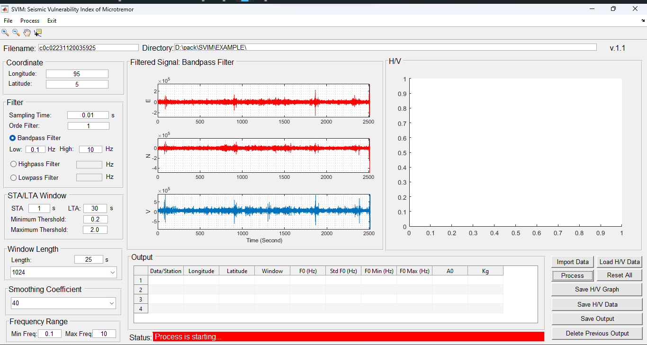

1. Once the process is complete, it will show HVSR curve, numbers of trigger window, and all output parameters (in table) as shown figure below.
2. Click Save H/H Graph button to save the current HVSR curve.
3. Click Save H/V Data button to save the current HVSR data (see Appendix A.1 for the format file).
4. Click Save Output button to save the all-outputs data from the Output table. ***Please note that, this function will useful if all of data have been complete processed.***

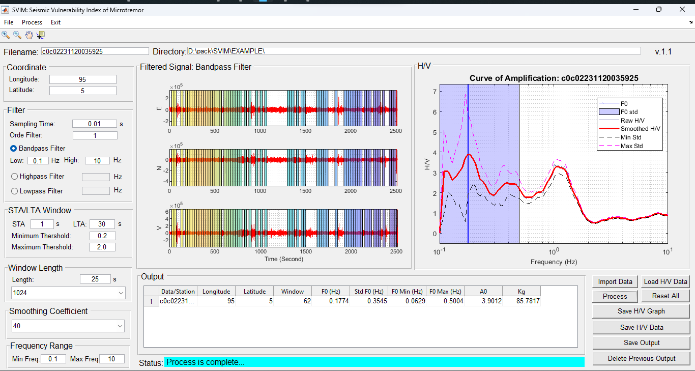

1. Once the single data observation of microtremor have processed, please import the next data to be processed by the same previous process.
2. Assume we have all complete data from all coordinates (see Appendix A.2 for example), then in toolbar click Process 🡪 Map (ctrl + P) to open SVIM-map window as shown in figure below.

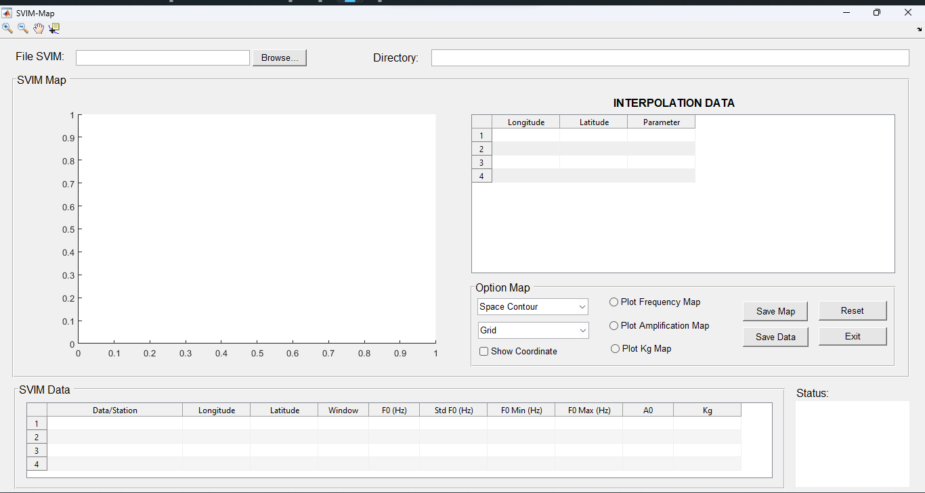

1. Click Browse button to open an example data of entire data (Output_SVIM.txt) and it will show as figure below.
2. Select the space contour parameter. There are five options, 10, 20, 30, 40, and 50. In this example, the 20 is choosen.
3. Select the grid parameter. There are four options, 50, 100, 150, and 200. In this example, the 100 is choosen.

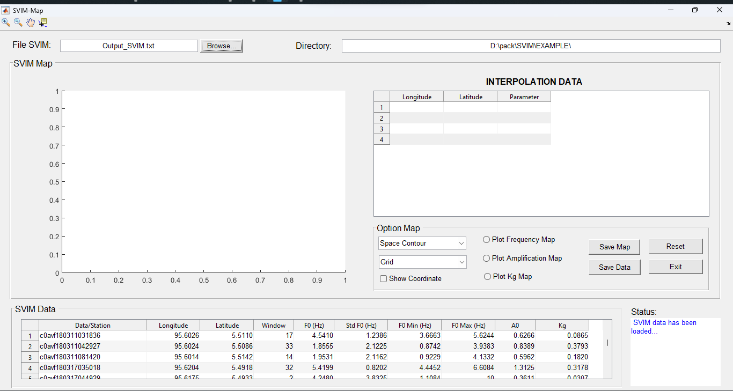

1. We can plot the output parameters such as $f_{0}, A_{0}$ and $K_{g}$. For example, $f_{0}$ is shown in figure below

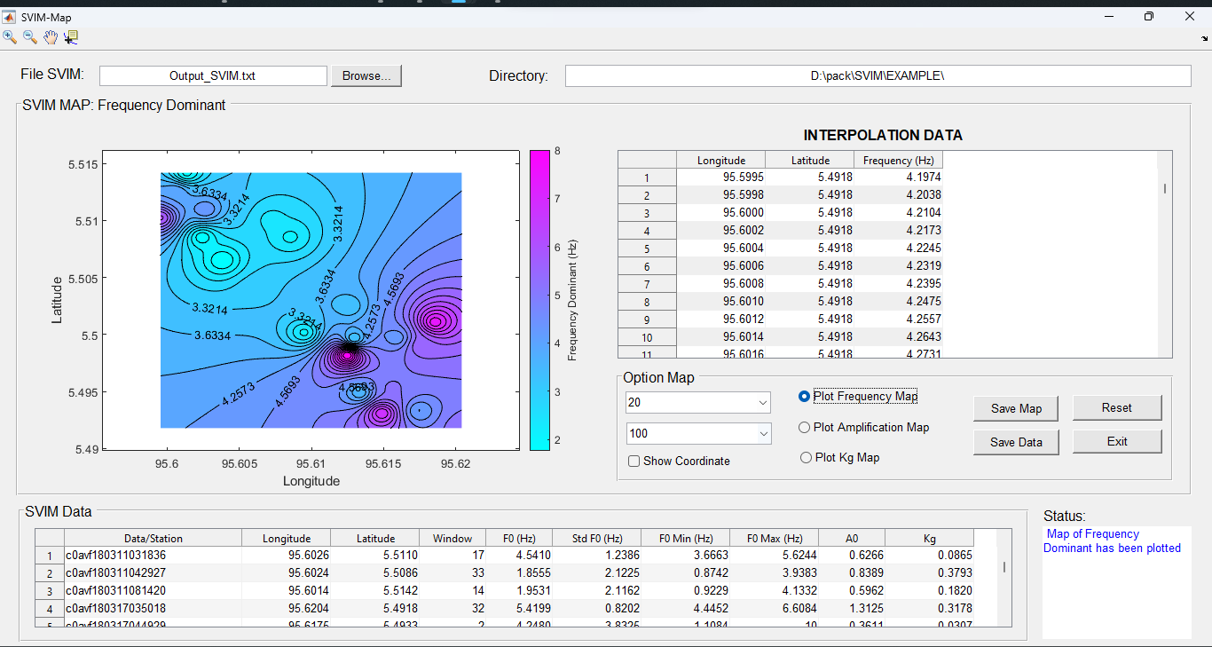

1. The interpolation data is shown in table and can be saved through the **Save Data** button.

# Citation

For the citation, you can refer to following DOI [10.1088/1755-1315/273/1/012016](https://iopscience.iop.org/article/10.1088/1755-1315/273/1/012016/meta) or [here](https://etd.usk.ac.id/index.php?p=show_detail&id=66042&keywords=aulia+khalqillah)­­

# References

Konno, K., & Ohmachi, T. (1998). Ground-Motion Characteristics Estimated from Spectral Ratio between Horizontal and Vertical Components of Microtremor. In *Bulletin of the Seismological Society of America* (Vol. 88, Issue 1).

Nakamura, Y. (1989). A method for dynamic characteristics estimation of subsurface using microtremor on the ground surface. *Railway Technical Research Institute, Quarterly Reports*, *30*(1).

Trnkoczy, A. (1999). Understanding and parameter setting of STA/LTA trigger algorithm. *IASPEI New Manual of Seismological Observatory Practice*, *2*, 1–19.

**Appendix A**

A.1. An example of HVSR curve data

|  |
| --- |
| Seismic Vulnerability Index of Microtremor (SVIM) Output  Station = c0c02231120035925  Longitude = 1.000000  Latitude = 2.000000  Window = 62  Length Window = 25  Standard Deviation (F0) = 0.354545  A0 = 3.901196  F0 = 0.177419  Kg = 85.781677  Fmin = 0.062903  Fmax = 0.500415  Freq H/V SpecH/V MinStd MaxStd  0.100000 0.000000 0.000000 0.000000 0.000000  0.109677 3.057424 3.057431 1.003111 5.111737  0.119355 3.040635 3.040684 2.045275 4.035995  0.129032 2.627310 2.627051 1.826192 3.428428  0.138710 2.773154 2.773081 1.413601 4.132706  0.148387 3.012610 3.012658 1.415212 4.610007  ….  …. |

A.2. An example of all observation outputs

|  |
| --- |
| Station,LONG,LAT,WIN,F0,STDF0,F0MIN,F0MAX,A0,Kg  c0avf180311031836,95.60264,5.51095,17,4.54102,1.238578,3.666315,5.6244,0.62658,0.08646  c0avf180311042927,95.60243,5.50855,33,1.85547,2.122515,0.874184,3.938259,0.83893,0.37931  c0avf180311081420,95.60136,5.51419,14,1.95312,2.116184,0.922947,4.133172,0.59624,0.18202  c0avf180317035018,95.62041,5.49178,32,5.41992,0.820151,4.445156,6.608442,1.3125,0.31784  c0avf180317044929,95.61746,5.49329,2,4.248047,3.832464,1.108438,10,0.361094,0.030694  c0avf180317055853,95.61488,5.4931,4,7.03125,3.417736,2.057283,10,0.4248,0.02566  c0avf180317074010,95.61552,5.49534,10,5.22461,1.046994,4.990106,5.470133,0.60881,0.07094  c0avf180317084059,95.61334,5.49491,10,3.66211,0.892441,3.268216,4.103476,0.9079,0.22509  c0avf180317095058,95.61248,5.49817,2,8.34961,0.069053,0.576569,10,2.29891,0.63296  c0avf180318023636,95.61856,5.50107,39,7.56836,2.844741,2.660474,10,0.98703,0.12872  c0avf180318033727,95.61763,5.49898,7,5.76172,1.193878,4.826051,6.878792,0.66561,0.07689  c0avf180318043710,95.6159,5.4997,19,4.3457,1.36743,3.178008,5.942443,0.65841,0.09975  c0avf180318071020,95.61296,5.49966,21,3.32031,1.374232,2.416122,4.56288,0.89124,0.23922  …  … |